Task #3

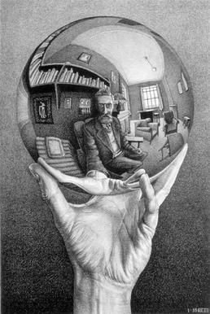

Figure 1 Hand with Reflecting Sphere. 1935. Lithograph 31.8cm x 21.3cm

Maurits Cornelis Escher Annotated Bibliography

Ernst, Bruno. *The Magic Mirror of M.C. Escher*. Taschen, 1976.

A study of the life and works of M.C. Escher. It shows many of the sketches, studies and diagrams which he made while creating his magical effects. His contribution to our understanding of perception and what we regard as possible or impossible.

“Escher, Maurits Cornelis.” Benezit Dictionary of Artists , 31 Oct. 2011, www-oxfordartonline-com.unh.idm.oclc.org/benezit/view/10.1093/benz/9780199773787.001.0001/acref-9780199773787-e-00059742.

This article creates the basis for the understanding of Marurits Cornelis Escher. Referencing Books and Bibliographys, Aution Records, and Museum and Gallery Holdings.

“Escher X Nendo .” *National Gallery of Victoria*, www.ngv.vic.gov.au/exhibition/escher-x-nendo-between-two-worlds/.

This was a groundbreaking exhibition that features the work of Dutch artist M. C. Escher in dialogue with the work of acclaimed Japanese design studio nendo. It was open from the 2nd of December 2018 till the 7th of April 2019.

Escher X nendo | Between Two Worlds is a groundbreaking exhibition that features the work of Dutch artist M. C. Escher in dialogue with the work of acclaimed Japanese design studio nendo. For more info: Escher X nendo | Between Two Worlds

“On My Meetings and Correspondence between 1960 and 1971 with the Graphic Artist M. C. Esche.” pp. 1–5. *The MIT Press*, 1982, <https://www.jstor.org/stable/1574338?seq=1>.

The author summarizes the correspondence with the Dutch artist, M. C. Escher. Thoughts, opinions, and other pertinent information on his work discussed along with some biographical information.

Paşcalău, Cristian. “Double-Crossing Images: Intentionality and Representation in the Work of M. C. Escher.” *Caietele Echinox*, Fundatia Culturala Echinox, 1 Jan. 1970, [www.ceeol.com/search/article-detail?id=476515](http://www.ceeol.com/search/article-detail?id=476515).

This article studies some aspects of the Dutch graphic artist M.C. Escher's work. It focuses mainly on how intentionality and representation convey a key for interpreting Escher's utterly impossible world.